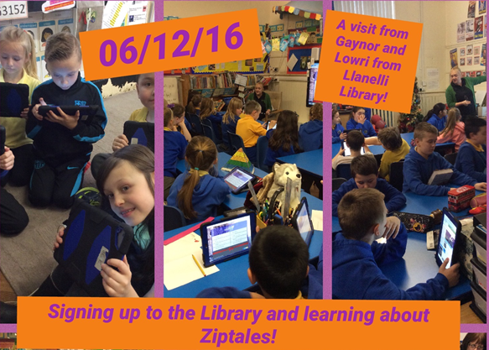

Hi Gaynor,

Just wanted to say thank you very much for visiting the school this morning. It was great to meet you and Lowri and I look forward to using the Library Service in the New Year.
The children are very enthusiastic and have promised to visit their local library with their new card!
Diolch eto,
Cara.

