A Year of Reading Daringly / Blwyddyn o Ddarllen Beiddgar
Our sites:
Facebook: A Year of Reading Daringly
Blwyddyn o Ddarllen Beiddgar
Twitter: @ReadingDaringly
@DarllenBeiddgar
Blog: http://readingdaringlydarllenbeiddgar.blogspot.co.uk/
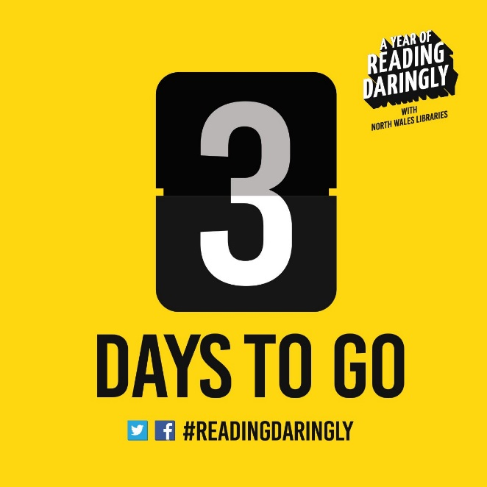
A

B.
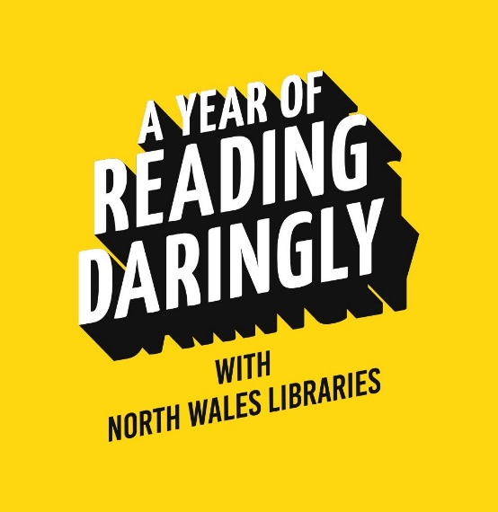

C. BBC Radio Wales Link
http://www.bbc.co.uk/programmes/b06s6yyf

D. https://www.denbighshire.gov.uk/en/resident/news/december-2015/Sign-up-for-a-year-of-Reading-Daringly-with-north-Wales-libraries.aspx

E.

From: Stuart Prebble [mailto:stuart.prebble@storyvault.tv]
Sent: 25 January 2016 17:16
To: Debbie Williams
Subject: RE: A Year of Reading Daringly with North Wales libraries

Hello Debbie - what a brilliant and enterprising initiative I am honoured and would be absolutely delighted to tweet and blog as your suggest. Rely on it. Very best, Stuart

Stuart Prebble
Storyvault Films | Bridge Studios | 107a Hammersmith Bridge Road London | W6 9DA
020 8741 3929
F.

From: Margaret Murphy [mailto:margaret.murphy911@gmail.com]
Sent: 12 May 2016 13:45
To: Cath Staincliffe
Cc: Debbie Williams; Ann Cleeves; Chris Simms; Kate Ellis-Bullock; Martin Edwards
Subject: Re: North Wales libraries
Dear Debbie,
This is great news! I've retweeted a few of your tweets and will dip into your conversations over the weekend.
Thanks for choosing Starlings, and Other Stories - we loved the project, and it does seem to have captured readers' imaginations.
All best,
Margaret
G.

H. http://readingdaringlydarllenbeiddgar.blogspot.co.uk/
I.
