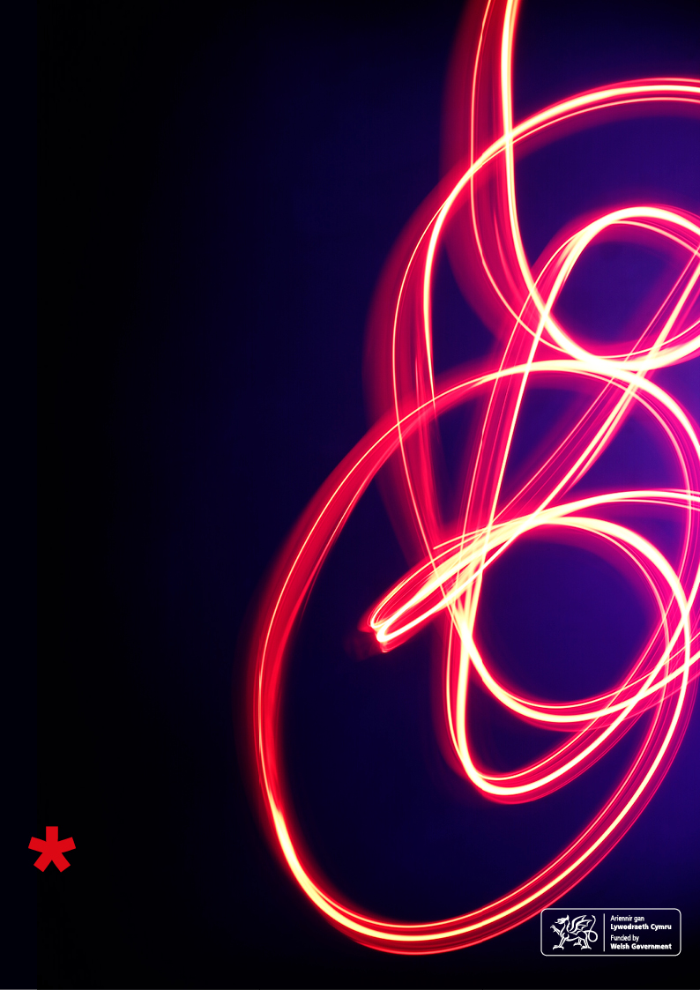

# CELEBRATING AND REWARDING MARKETING EXCELLENCE IN WELSH LIBRARIES, ARCHIVES AND MUSEUMS

#marketingawards

## MARKETING

## EXCELLENCE

## AWARDS

## 2017

## Entry form

ENTRY FORM FOR CATEGORY 1: DEMONSTRATING MARKETING EXCELLENCE AND CATEGORY 2: JOINT MARKETING PROJECT OF THE YEAR

Please complete this section if you are entering Categories 1 and/or 2 only. Please note these details will be used for all future correspondence regarding this specific entry. All fields are compulsory. This information will be used for publicity, therefore please ensure all sections are completed accurately.

**Title**  Mrs  **Ms**  Miss  Mr  Dr  Other

|  |  |
| --- | --- |
| First name | Victoria |
| Surname | Rogers |
| Job title | Museum Manager |
| Organisation name | Cardiff Story Museum |
| Organisation address | The Old Library, The Hayes |
| Town | Cardiff |
| Postcode | CF24 3JY |
| Email address | vrogers@cardiff.gov.uk |
| Twitter account @ | @thecardiffstory |
| Organisation profile/overview 100 words maximum | |
| Cardiff Story Museum opened in April 2011. Telling the story of Wales’ capital city, it is a community-centred museum, co-created with the Cardiff public. A fully Accredited museum, it collects, preserves and interprets Cardiff’s heritage for present and future generations – so locals and tourists alike can find out how the city we know today has been created, and how important we all are to that story. Through its collection, displays, activities and projects, be that on-site or off-site throughout the county, the Museum encourages active engagement with the area’s history and its diverse communities. | |

CATEGORY ENTERED (please tick):

Category 1 – Demonstrating Marketing Excellence

Public libraries  Further education libraries  Higher education libraries

Health libraries  Archives  **Museums**

Category 2 – Joint Marketing Project of the Year

Joint Marketing Project of the Year

The total word count for the section below must not exceed 2500 words. A maximum of two additional documents may be submitted to support your entry not exceeding 5MB in total or provided as a ZIP file. Alternatively please provide relevant links.

Project title

Enter the title or name of the marketing project – this will be included in all relevant publicity.

|  |
| --- |
| We Are Five |

Context

Describe the background/reason for this project. What challenges or opportunities were you faced with?

|  |
| --- |
| We Are Five was a project to celebrate the Museum’s fifth birthday. However, the context and background to the project meant this was more than simply a birthday party. The Museum team were determined to maximise the opportunities presented by the anniversary, to reach those who had not heard of the Museum, or who had not yet visited, to positively communicate the Museum’s achievements during its first five years, and to evidence its value to Cardiff’s communities, identity and cultural life.  The Cardiff Story Museum is physically small and therefore it is often difficult to compete with Cardiff’s larger cultural entities, such as National Museum Wales, St Fagans, Techniquest, Cardiff Castle, Cardiff Bay, etc., in terms of attracting both tourist and local visitors. When added to the fact that the Museum has little dedicated marketing or events budget and no marketing staff, it is true that the Cardiff Story sometimes struggles to get its voice heard within the market.  There was a recognition that the birthday could present an opportunity to ‘make a splash’ and gain additional publicity for the Museum. The birthday was also seen as a chance to re-engage those who had been so supportive of the Museum’s development. For example, the South Wales Echo had been incredibly supportive of the project to establish the Museum, running several series of double page spreads, appealing for objects and stories during the museum’s development phase. This support had waned somewhat after opening, as staff both at the Echo and within Cardiff Council’s communications team had moved on and relationships with the Museum had been lost over time.  The anniversary coincided with Yr Hen Lyfrgell (Cardiff’s Welsh language centre) opening within the Old Library building in March 2016. While presenting many positive opportunities for reaching new audiences, it had also unfortunately resulted in the perception among many that the Museum had closed. The anniversary therefore presented the opportunity for a large scale event to communicate that the Museum was very much still open and operating within the building.  It is certainly true to say this project was undertaken on a shoestring, and all marketing activity was undertaken at minimal cost. However, this project is an example of how a small museum, with nominal resources and no specific marketing expertise, can run a successful campaign. It also demonstrates the power of local museums to advocate their worth and communicate their impacts to stakeholders and funders. |

Aims and Objectives

State the aims and objectives that were set for this project – where possible these should be SMART objectives – for example, how many new users or people attending the event were you hoping for?   
If possible, include budget and timescale information.

# What is a SMART objective? Specific, Measurable, Achievable, Realistic, Time-bound

|  |
| --- |
| The overriding aim of the project was to take advantage of the opportunities offered by the Museum’s 5th anniversary of opening. Through this there were five core objectives of:   1. To run a successful family fun day to celebrate the Cardiff Story’s 5th birthday   Attracting new and repeat visitors to the Museum for a special event; gaining additional publicity and press for the museum  *Measures*: activities held during the day; audiences targeted; numbers attending; positive comments from attendees   1. To attract 400 people to the event   Increasing the amount of attendees usually attracted to the Museum’s special events (c.50-200).  *Measures*: number of people attending   1. To re-engage previous supporters and participants   *‘*Getting back in contact’ with the hundreds of people who had worked, volunteered, donated objects and stories, worked on partnership projects, supported the Museum during its development phase and the first five years of its life.  *Measures*: contact made to, and received from, previous supporters/volunteers/participants; evidence of continued contact following event   1. To reinvigorate the Museum’s relationship with the Echo newspaper   Fostering a positive relationship again with the Echo for the event itself, and ongoing  *Measures*: contact made with Echo journalists and relationship formed; articles published in newspaper/online; evidence of continued support following event   1. To demonstrate to the museum’s stakeholders and funders its worth and value   Communicating the impacts that the museum has made on people’s lives during its first five years, exploding the myth that museums are just about ‘old things in cases’.  *Measures*: evidence of impact pulled together; formats/forms used to communicate with stakeholders; evidence of impact of that communication  The project had a deadline of the museum’s birthday (1st April), with the event being held on Saturday 2nd. Work began mid-January to plan the event itself, the marketing surrounding it and how to achieve its objectives. A budget of £1,500 was allocated. |



Strategy & Planning

Outline the strategy taken to achieve your objectives and justify your marketing approach – did you undertake any research for example; have your developed new or existing partnerships; did you target a new audience or try a new approach to promoting your services?

|  |
| --- |
| * Two core **target audiences** of families and previous/current supporters, users and participants were determined. * A **target of 400 attendees** was set. The team felt this was ambitious, yet achievable if the Museum was targeted in its marketing, if the event was designed to be of interest to its audience, that time and effort was taken to contact potential attendees directly, and if the Museum achieved the buy-in from the Council’s Communications team * Informal **consultation** was held with the Museum’s current users and visitors (eg. attendees at the Museum’s monthly Dinky Dragons and half term events, general visitors, contacts in relevant organisations) to determine the type of events and activities that might attract families to attend. * The Museum team (front of house, back of house and volunteers) brainstormed and input **activity ideas** for the fun day. * While to the public the aim was to provide simply a fun day out, there was to be an **underlying theme** of ‘impacts the Museum has made’. The event was to involve the community, to echo the Museum’s ethos of community centred working. * The team pulled together a series of **statistics**, facts and figures relating to its work from 2011-2016. * A **contact list** of previous volunteers, supporters, donors, stakeholders, participants and community organisations was created. * The Museum Manager wrote a **‘pitch’** for the Council’s Communications team and for the South Wales Echo, in order to gain support for the event and to secure their help to publicise the museum and the event. * A **marketing plan** was created, taking account of the aspirations and objectives of the event, and the reality of the resources the Museum had. * Thought was given to how to market the event in the run up, but also how the event could be publicised ‘on the day’. * Social media was identified as being the key method of communication that would be utilised to publicise the event. Thought was given how to maximise reach of posts. |

Tactics and Implementation

Set out the plan of activities undertaken to implement the strategy and evidence these over time and against budget. Include examples if appropriate – you may append or link to two additional pieces of supporting evidence – if internet links are included please ensure these will remain live until March 2017. What promotional activity did you undertake; did you use social media and/or traditional media?

|  |
| --- |
| The activities framed for the event all adhered to the theme of impacts or Cardiff’s history. The music was provided by Sororitas Choir who had previously worked with the Museum on two events and by Shipbuilding band, who had written a series of songs inspired by Cardiff. The Museum approached Cara Maiden to make the birthday cake. Cara had won the Museum’s Cardiff Cake Off event in 2014, and as a result appeared on Channel 4’s Kirstie’s Homemade Christmas, had given up her job as a doctor, and opened a teashop and cake decorating business. A Cardiff face painter was sourced, craft activities ran throughout the day with the theme of ‘birthdays’ and Cardiff’s animal wall, and sessions for party games, story time and rhyme time also took place throughout the day.  Budget:  £300 Freelancer for crafts activities, incl. materials  £100 Face painter  £165 Balloons and holders x 100  £340 Badges  £340 Balloon towers for entrances  The cake maker and musicians all gave their time for free, to support the Museum  Total: £1,445  Resources were purchased to ‘give away’ to visitors, that would also act as attractors on the day when seen being carried around the city (balloons) and reminders to return at a later date (badges). The Museum also sited balloon towers at its entrances to attract passers-by.  General publicity materials were designed and printed in-house to save costs. Flyers and e-posters were distributed to relevant organisations, venues and individuals. Opportunities to publicise the day on-site at the Museum were also maximised. Posters and flyers were sited throughout the galleries, on toilet doors and were personally given to visitors by the Front of House team. Team members also spoke to attendees at the Museum’s regular events (Dinky Dragons, Reminiscence Monthly and school holiday workshops) and with project participants, to encourage attendance.  Contact was personally made with as many previous donors, funders, supporters, participants and volunteers as possible via telephone, email or sending invitations in the post.  Meetings were held on site at the Museum with the Council’s Communications team and the Museum Manager to encourage them to support the Museum’s campaign and to broker contact with the South Wales Echo. A meeting was set up with the Echo’s local government reporter to discuss the history of the newspaper’s involvement in the development of the Museum, and to seek support in publicising the anniversary and the event. As a result, a commitment for two articles in the fortnight before the event was secured and the Council Communications team agreed to feature the event on the intranet, in staff communications and on the Council’s official facebook site.  During March, the month leading up to the birthday event, the Museum released a tweet/facebook message each day using the hashtags #WeAre5 #5oed. Each message used a statistic or fact about the Museum’s first five years, demonstrating its impact and work with communities. They were often retweeted by Cardiff Council, the Council’s Leader and the councillor with the culture portfolio. Thought was given to maximising the reach of the messages. Relevant tweets were coincided for relevant national events (eg. Access Day, Museum Week themes, National Apprenticeship Week) and corresponding hashtags added. The Museum also used the hashtag #maketheDifference which the Council was using at the time to emphasise the difference and impacts made by its departments to the inhabitants of Cardiff.  The statistics and quotes from visitors and participants were also used to create an e-booklet “Cardiff Story Museum: celebrating five years” which was sent to stakeholders, councillors, funders and supporters.  The booklet and examples of our marketing during the campaign are attached. All were created in-house and as digital copies to reduce costs.  Please note: all the marketing and the booklet was fully bilingual. To adhere to the award’s rule of attaching no more than two documents, we have attached the English versions. The Welsh version is of course available if required. |

Results/Measurements/Outcomes

Present the results of the project, state whether your aims and objectives were achieved and if they were delivered on time and within budget. Evaluate the project using measurements where possible, such as number of new members/visitors, added value to the organisation and digital marketing metrics where applicable (Google Analytics, Facebook insights, Tweetreach). Reflect on what could have been done better; is the project sustainable, could it be rolled out to other user groups or organisations?

|  |
| --- |
| * The impact of the social media campaign during the month prior to the event was extremely pleasing. Messages with the #WeAre5 and #5oed hashtags attracted 57,699 impressions over twitter and 29,226 impressions on Facebook. A video publicising the event on the Council’s Facebook site attracted 243 views. * Just over 600 people attended the event and feedback was overwhelmingly positive. (eg. <https://welshmummyblogs.wordpress.com/2016/04/02/happy-birthday-cardiff-story-museum/>) * The event ran from 10am to 4pm, with many any families stayed for several hours, almost completing a trail of the different activities on offer. * Existing and current visitors and participants supported the event – Dinky Dragons attendees (many bringing their older brothers and sisters!), volunteers, Reminiscence Monthly attendees and members of organisations the Museum was working on partnership projects at the time (eg. members of the Durga Puja committee) * The event attracted new visitors who had come specifically as they had heard about the event via the Echo or social media/word of mouth. * Many of those visitors are now seen regularly at the museum – taking part in Dinky Dragons (monthly baby and toddler events), school holiday fun days and our Reminiscence Monthly events. * Many supporters, donors, participants and volunteers from the Museum’s development returned to celebrate, most of whom had lost touch with the museum over time. Several are now still regularly involved with the museum, attending Reminiscence Monthly sessions. Old Dinky Dragons attendees (now of school age) returned for the event, and ex-members of staff also returned to say hello on the day. * The objective of reinvigorating the Museum’s relationship with the Echo newspaper also was achieved. Prior to the event, the Museum wrote two articles about Cardiff’s history for the paper and its Wales Online content, which also publicised the Museum’s anniversary and the birthday event. For example: <http://www.walesonline.co.uk/lifestyle/fun-stuff/16-fascinating-things-you-probably-11113395> * On the day itself, a journalist and photographer attended and wrote a piece for the Monday edition: <http://www.walesonline.co.uk/whats-on/family-kids-news/happy-birthday-cardiff-story-museum-11130885> * Pleasingly, the relationship with the South Wales Echo has continued post-event, throughout 2016, with the Museum featuring regularly in articles and listings both online and in print. These articles have increased the reach of the museum, not only in terms of the printed distribution of the newspaper itself, but also in terms of the readership of Wales Online versions, many of which have also had positive numbers of ‘shares’.   This has comprised the Echo ‘automatically’ including the museum in listings articles; evidence that Echo journalists are now more knowledgeable of the museum’s existence and its activities. For example:  11 July 2016 - 32 things to do for FREE in the summer school holidays in Wales  <http://www.walesonline.co.uk/whats-on/family-kids-news/32-things-free-summer-school-11597328>  (3,228 shares)  2 January 2017 - Cardiff Bucket List  <http://www.walesonline.co.uk/whats-on/whats-on-news/cardiff-bucket-list-30-things-12393871#ICID=sharebar_twitter>  (1,681 shares)  Journalists have also contacted the museum to ask for content, or to check “what you’re doing” when charged with writing culture-based articles. Again, this indicates that the Echo has a greater understanding of the museum’s content and activities. For example:  23 July 2016 - Roald Dahl Trail  <http://www.walesonline.co.uk/whats-on/family-kids-news/went-roald-dahl-trail-cardiff-11636679>  (798 shares)  In addition, the newspaper has approached the museum to write historical, fact based articles for inclusion, or to check facts on internally produced articles. This is particularly pleasing as it indicates the museum is becoming a key point of contact for journalists when writing about Cardiff’s history and identity. For example:  2 June 2016 - 10 fascinating facts about Cardiff’s past  <http://www.walesonline.co.uk/lifestyle/fun-stuff/10-fascinating-secrets-cardiffs-past-11387766>  This article worked particularly well. We were told by the reporter who commissioned the piece that by 3.30pm that afternoon it was the top article being read on Wales Online, with twice as many readers as anything else on the site.  (4,121 shares) |



Date of Project

Provide the start and (if appropriate) finish dates of the project.

|  |
| --- |
| January – April 2016 |

Summary

Provide a brief summary of your project (approx. 150 words) to be used for promotional purposes on the website, social media, etc.

|  |
| --- |
| We Are Five was a campaign to celebrate the Cardiff Story Museum’s fifth birthday. Culminating in a large family fun event, the month long campaign sought to attract new visitors; re-engage with previous supporters, participants and object donors; reinvigorate its relationships with media partners; and positively communicate the Museum’s achievements during its first five years, evidencing its value to Cardiff’s communities, identity and cultural life. Achieved with minimal budget and no dedicated marketing staff, We Are Five is an example of how social media and personal contact can be utilised to reach new and existing audiences, and to advocate value. |

ENTRY FORM FOR CATEGORY 3 – MARKETING CHAMPION OF THE YEAR

Please complete this section if you are entering Category 3. Entries must be nominated by a manager or equivalent – you cannot self-nominate. The nominee must give consent to be nominated.

# Please tick the relevant box below

# Library Marketing Champion

# Archives Marketing Champion

# Museum Marketing Champion

|  |  |
| --- | --- |
| Name of nominator |  |
| Job title |  |
| Organisation name |  |
| Organisation address |  |
| Town |  |
| Postcode |  |
| Email address |  |
| Twitter account @ |  |



Why are you nominating this person?

The total word count for the section below must not exceed 1000 words. A maximum of two additional documents may be submitted to support your entry not exceeding 5MB in total or provided as a ZIP file.

Alternatively please provide relevant links.

# Notable achievements Challenges and barriers overcome

# Differences made to the service New partnerships

# Examples of innovative or creative working Examples of engaging colleagues in marketing

|  |
| --- |
|  |

Contact details of nominee

|  |  |
| --- | --- |
| Name of nominee |  |
| Job title |  |
| Organisation name |  |
| Organisation address |  |
| Town |  |
| Postcode |  |
| Email address |  |
| Twitter account @ |  |

Please submit the entry form and any additional documents to jane.purdie@wrexham.gov.uk by 20th January 2017.

Thanks for entering the Marketing Excellence Awards 2017.

# 