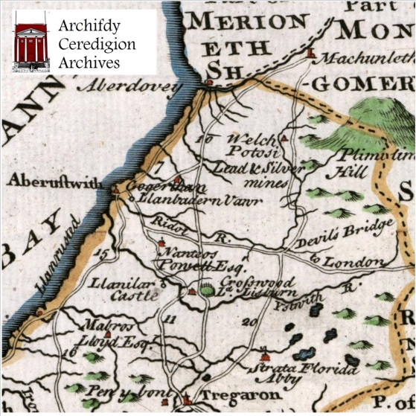

(above ) front and back of one of the ‘beer map’ designs ( below) the napkin design – printed on a nice parchment cream colour

