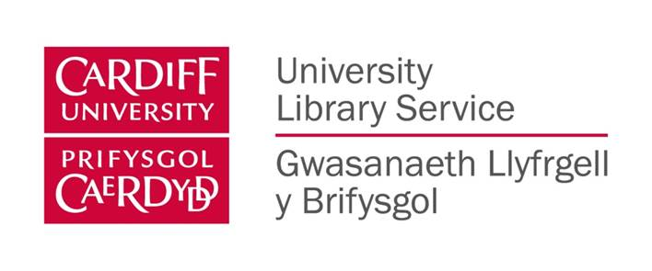
2016/17 ULS Marketing Calendar – November 2016
Themes/ dates | Lead(s) from marketing | Network members | ULS Partners | Activities
November  Reading list feedback event & launch of new intranet page on how to read a reading list?  Feedback 21st to 27th Nov  Theme : “Spotlight on your reading lists” | HS  SE  SP |  | RM  (Reading List Group Lead)  & Business Analyst (DM) | Planning: Meetings held with Reading List Group Lead (Rebecca Mogg), David Melkevik and Sue Elias) 19th September.  Meeting with project group held 24th October  Weekly meeating to be arranged from 31st October 2016  Notes:
Survey questions  Deadline:  14/11/16  Survey analysis  Deadline end Jan 2016 | SE/RS  HS | ALL | RM & DM | Questions (on access & quality of reading lists) to be drafted – Done.  Formatted by RS  Survey Monkey version RS  Done  All comments to be typed and sent to HS w/b 31/11/16  HS to collate and send to DM  w/b 12/12/16  DM to code and analyse results and share with Subject Librarians by w/b 30/1/17
Intranet page  Deadline  18/11/16 | SE |  | RM | Intranet page will be created (student & staff) with guidance on understanding your reading lists.  Done
Display material  Deadline  11/11/16  In site by 14/11/16 | RS/SP/SE |  | n/a | 3 elements (A2 or A3posters) and a banner using a film review theme to attract attention:  • 1 The story so far: ULS action on reading lists (investment, ebooks, online ordering improvement on delivery times, guidance to academics, digitisation, intranet page etc.)  •2 Feedback on post it notes ( displaying comments from forms)  • 2 Coming soon ( intranet page & online reading lists)
Guidance for Network members on promoting feedback forms  Circulated by 14/11/16 | HS |  | n/a | Advice to staff to be circulated on generating feedback from users e.g. placing feedback forms on enquiry desks, study areas and social areas, best use of sweets. Done.  Picktochart poster and email HS.
Social & Digital Media  Deadline 14/11/16 | RS |  |  | Social Media Rs to devise a hashtag for the event which will be used to promote the in site activities and share feedback throughout the week. Done  Liaise with Social Media Group to agree timetable of tweets/ retweets using #CUReadingLists Done  Monitor online survey results from 21/11/16 (RS)
User incentives:  Deadline:  Circulated 14/11/16  Max cost:  £100  Staff incentives | HS/SE  HS/SE |  |  | Purchase of sweets and prize draw (Blackwells voucher).  Costco £48  Poundland £25 Done  Staff incentive: prizes ( boxes of biscuits) for sites gathering most feedback forms: 3 categories  Large: ASSL, Bute/ Architecture, Health  Medium: Aberconway, Science, Trevithick  Small: Aberconway Guest, Archie Cochrane, Biomed, Brian Cooke Dental, Julian Hodge, Music, Postgraduate Study Zones, Senghennydd,
Rota for stands/ Subject Librarians  21-27th |  | ALL  DM  RM | Subject Librarians | Rotas in each site for SL & DM slots.  Send to HS on 28/11/16  More direct engagement with users – DM will tour site with his t-shirt! He will be using Snap chat to capture feedback.  Focus on staffing stand or encouraging users to complete the form at enquiry desk.  Subject Librarians will be encouraged to cover the stands (RM has consulted with College Leads).
Communications  Before  After | HS |  |  | Email to Marketing Network with survey forms & rota template sent 14/11  Email to Customer Services Managers sent 14/11  Email to Subject Librarians by site 16/11 explaining their role and College Lead support. Done  Announcement of staff prize winners  26/11/16 (chosen by Deputy Librarian) Done  Contact student prize draw winner 8/12/16 Done  Book ULS Briefing for presentation Feb 2017

