Peter Pan Panto

The Event
With the help of local poet and children’s entertainer Librarians and Volunteers wrote and performed a pantomime based on the Peter Pan and Wendy story. A small stage was set up on the street in front of the library steps. The pantomime was performed on the stage and down on the street during Bridgend’s Christmas market day and included comedy, music and Father Christmas who appeared at the end. As a finale children were invited to get up and dance with the performers to the popular Gangnam Style. Sweets were then handed out to children and adults.

Aim
The aim of this project was to raise the profile of the library service amongst non-users and to increase membership within the Bridgend central area. We particularly wanted to encourage non-users to reassess preconceived ideas that they may have about the library service and to provide up to date information to the public about library facilities and relevance to children and young people. We wanted to provide a fun event that would help to dispel stereotypical ideas about how the library service operates whilst raising the service profile and getting people talking about us in a positive way. Ultimately the aim was to increase membership amongst non users.

To reach our target audience we decided to take the library service out onto the street on a busy day. To attract the most footfall it was decided that the event would take place during Bridgend’s popular Christmas market Day. Many people from the Bridgend Borough visit the market and were likely to come across the pantomime either by accident or design.

Target audience
We wanted to target people of all ages. We chose a pantomime as this is a traditional Christmas event that appeals to all. We aimed to make the performance as colourful, musical and as funny as possible to keep the audiences attention. There was no charge.

Partnership
We worked with local poet and children’s performer to create a funny, colourful pantomime. We borrowed costumes from Porthcawl’s Grand Pavilion theatre.

Publicity
Posters and flyers were created and distributed around Bridgend Libraries and Bridgend Town Centre businesses four weeks prior to the event. The event was included in the Bridgend Libraries brochure Bridgend Libraries website, Facebook and Twitter accounts were used to promote and encourage attendance. Bridgend council also encouraged followers via the Bridgend council twitter account. On the day staff walked the streets of the town centre inviting people to the event.

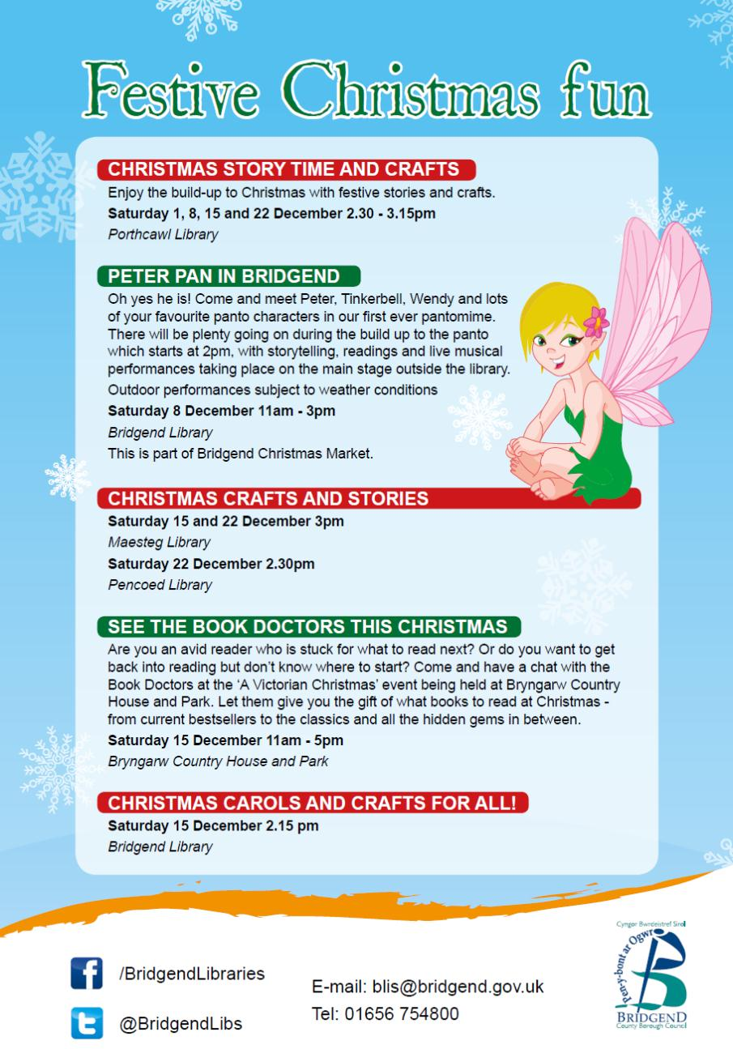

Staff
Five enthusiastic members of library staff, one member of staff from Bridgend Arts and culture department and a volunteer from Brynteg Comprehensive were available on the day to perform, provide information about the service and sign up new borrowers.

Cost

Design, Printing, Translation £200
Costumes (borrowed) £000
Performers fee £150
Stage Hire (borrowed) £000

Total £350

Evaluation and Outcome
Parents and carers were asked to fill out media release and evaluation forms. Data was gathered for a distribution database.

34 evaluation forms were returned on the day all responses were positive.

Quotes taken from evaluation forms:

“Amazing performance, really professional” (parent)

“Fabulous, can’t believe this was done by library staff” (parent)

“It was really funny!” (child)

“That was brilliant hope to see more of this kind of thing” (passerby)

“Lovely, especially for children who don’t get to see this kind of thing” (passerby)

95 children attended the event (approx.)
107 adults attended the event (approx.)

7 new junior members were signed up to the library at the event
8 new adult members were signed up to the library at the event

Facebook followers increased by 5 in the week after the event
Twitter followers increased by 14 in the event after the week

Feedback from the event was positive. We counted over 200 people who stopped and stayed to watch the performance. We feel that we managed to reach an audience that we might not usually. We received lots of positive comments and there was an enthusiastic ‘buzz’ on the day. It was felt that we went some way towards dispelling negative stereotypes about the library at this event

It has been agreed that a similar event following the same format will be held next year.

