Step in, Step up to Success… and Stress less!
Our objective was to focus on specifically students’ first assignments and to offer practical advice and tips for reducing stress, by highlighting the resources and services available in the library as being particularly relevant. It was held in the Hugh Owen Library on 7th Nov 2012, National Stress Awareness Day, which we hoped would coincide with forthcoming deadlines. Our event being funded as part of the Libraries Inspire health and well-being campaign, Get reading, Get better, Get libraries, was particularly timely.
It brought together staff from across the university and outside to raise awareness of the resources available to help with assignment preparation in particular and a healthy approach to academic work in general. The Health and Well-being campaign was used as a focus to impress upon students the importance of good health and well-being for successful study. The presence of a representative from Ceredigion Library allowed us to highlight the importance of reading for pleasure as a healthy activity.

A slight change of plan…
Although our original bid was for an event to be organised by Information Services within the Hugh Owen Library, we discovered when we approached them with a view to their taking part in our promotion, that colleagues in the School of Human Sciences (Psychology and Sports and Exercise Science) had independently decided to mark National Stress Awareness Day with some sort of event.
Consequently, we joined forces and together devised a university-wide Stress Awareness Day, the first time the University has come together in this way. Our objective was to make students and staff aware of the wealth of resources and services available to them over and above lectures and traditional teaching.
This involved close collaboration with a range of AU departments: Information Services staff (mainly Academic Services, Media & Print Services, Customer Services and E-services & Communications) together with the Students’ Union, Residential Services, Student Support Services, the University Sports Centre, Human Resources, the Departments of Sports & Exercise Science and Psychology. We gratefully acknowledge their assistance in making the event a success. In addition, Abigail Crook joined us with a stand representing the public library and we advertised membership in a campaign leading up to the event. We also used the day to launch our More Books campaign, an Information Services scheme which allows students themselves to choose books for purchase for the university libraries and our new Campus Fitness Maps, produced by students (in association with Information Services) to encourage walking between university facilities and services. We held the event on the ground floor of the library with stands for our writing experts and a dedicated area for our health and fitness expert, Rachel Hubbard, from the University Sports Centre. Visitors were surprised to be able to try out breathing and relaxation techniques actually in the library. This innovative use of space was successful and we aim to repeat this in future.
The programme for the day:
1:15 Launch of More Books campaign
1:30 Free healthy food & pick up a Book Menu
1:30, 2.00, 3.00
Ten tips for good essay writing – John Morgan
1:45, 2.45, 3.45
Relaxation hints and tips - Rachel Hubbard
1:00 – 4:00
Questions for your Subject Librarians,
Get advice from the Royal Literary Fund Writing Fellows,
Talk to Careers
Talk to and join the Public Library

Marketing and Publicity
Our original bid had proposed a trail around the stalls in the library, but the new, bigger event developed this idea into a Campus Trail competition, with the entries received at the Library and the winning entries drawn at the end of the week. Publicity was extensive and included leaflets printed and distributed campus-wide (these were also the entry forms for the competitions), posters, notices in the weekly email to staff and students, an item in IS News, and notifications via FaceBook and Twitter. All publicity was fully bilingual and credited the sponsorship of the event. We made extensive use of the ‘empty belly’ poster designs provided and these drew many favourable comments on the design. Balloons helped draw attention to the event and we handed out the branded stress balls to participants in the relaxation sessions. Prizes awarded included a massage (from our bid funding), a personal trainer session, a swim pass and a gym pass (provided by the Sports Centre).

Attendance
The event drew about eighty students into the library specifically to engage with the event (rather than just going through to the upper floors), which was a little disappointing, but the widening of our focus on stress awareness to include events taking place all over campus somewhat diluted our gate figures. Many of the students passing through explained they had assignment deadlines that week; otherwise they would have taken part. Informal discussion with students at the Enquiry desks in the subsequent days suggested this was common. Unfortunately our attempts to discover assignment deadline dates at the point of promoting the event had been unsuccessful as a problem with central timetabling had made it impossible for the dates to be accurately predicted at that point. This is something to bear in mind for future years.

Events at the other venues on campus were reportedly well attended with take-up of blood pressure monitoring and free massages being unsurprisingly high!

Links to the campaign’s overall objectives and key messages
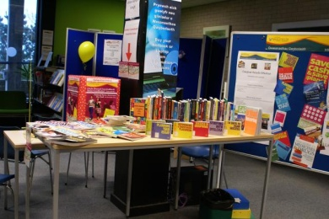
We highlighted both library and university health and fitness resources in addition to the study resources of the library. Our customers are accustomed to our services (books, internet etc.) being free, but we added value by giving advice on how to approach assignment writing, at a time when the information was particularly meaningful. We explained what academic staff are looking for when they set assignments, what resources, help and support are available and how a student can aim for better marks. This allowed us to demonstrate the expertise, helpfulness and friendliness of staff to students who may not otherwise have asked for assistance.
We showcased our collections of study skills books and life skills books as well as our modern fiction collection. The Effective Study collection covers such topics as how to research and study, writing skills, academic writing, English usage, time management, communications skills and some general guides to research and study in the arts. The material is intended for all users, including those for whom English is not their first language.
Talks by colleagues from the other departments involved proved very popular and visitors expressed appreciation of the opportunity to talk one-to-one to them, to Careers representatives, to the RLF Fellows and to the Academic Services Subject Librarians. We also showed ‘Vox Pops’ of 2nd and 3rd year student advice from last year.
We emphasised reading for pleasure by raising awareness of the public library. Their feedback was:
“From the point of view of the public library we had the chance to promote the library’s existence (!) and services to a range of students in all years of study many of whom were unaware of the public library and certainly not aware of its resources nor potential benefits. Some of the students with whom I spoke were confusing the public library with the national library and did not understand the difference. I’m glad I got the chance to explain where and what we are and what we offer. I feel it has been potentially very beneficial both from our perspective and those of the students as they may now take advantage of the study and relaxation space and resources available in town and online services.”

Our offering of a huge carrot cake tray bake, fresh British fruit and fruit juices was extremely popular and proved that you can attract new audiences by offering them good nutritious treats! We ran out of Book Menus very quickly too.
Staff time is at a premium especially in the first semester, so the event organisation was done by just two people so that the specialists only had to turn up on the day. The comprehensive planning document created last year was kept up-to-date and has had reflections on the event added so that it can be used for planning similar events in future years.

Evaluation
A member of the Academic Services Team recorded new ‘Vox pop’ interviews with students using a flipcam. The responses obtained will be used to inform the content of future Study Skills sessions offered. The following information gathered from the interviews will be useful to us in planning for the future:
- Causes of stress:
- Distractions
- Working in silence
- Working at home
- Meeting deadlines
- Being in second year
- Demand to achieve
- Many assignments due in one time
- Accumulating work over a period
- Volume of studies
- Being dyslexic
- Ways of managing stress
  - Support from tutors
  - Working in groups
  - Doing a little bit at a time
  - Taking a break and chatting with friends
  - Listening to music
  - Drinking coffee
  - Taking a break to read a good book
  - Going out for a short walk
  - Going out to view scenery in Aber
  - Doing something different
  - Learning to focus
  - Eating cakes
- What the library can do
  - Provide help
  - Support for finding materials
  - Provide silent and non-silent zones
  - Monitor use of spaces
  - Utilise spaces more effectively
The table below shows the most common queries received at the Academic Services librarians’ stand, listed by department, where the department was given. These data are useful in helping staff refine their focus on information literacy training provision.

Biological, Environmental & Rural Sciences | Staff | key guides
Sport & Exercise Science | UG | finding resources
International Politics | UG | zetoc, endnote, fiction sources
Mathematical & Physical Sciences | UG | e-shelf, more books, subject info, endnote
Law and Criminology | UG | subject guides, where to find help
International Politics | UG | subject guides, where to find help
Theatre, Film & Television Studies | UG | searching, e-shelf, referencing

We focussed on exam skills at a similar event last year, which was held at a slightly different time. Although the library was absolutely full at the time this year’s event took place, it proved almost impossible to attract students away from their books and laptops to come downstairs and join in, so timing needs to be addressed carefully for future events.

Some comments from students and staff:
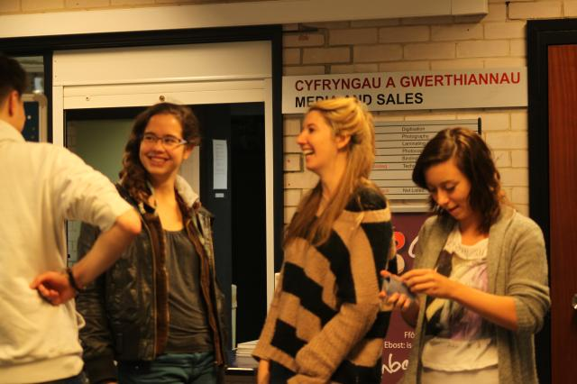
“It was great to talk to the writing specialists”

“I don’t like asking for help. Having it put in front you makes it easy”
A number of students spoke privately to the representative of the Sports Centre who gave the relaxation tips session, and as a result she organised further sessions in the following couple of weeks and has now incorporated them into their timetable of events, especially their Fit and Well campaign that runs throughout reading week and the exams.
“It was useful to spend a bit longer with each person and raise awareness about e.g. the Primo E-Shelf, the More Books campaign, referencing software, alerting services etc.
“I’m sure I’ll be using Rachel’s relaxation techniques again soon.”
“It was nice to meet Abby the community librarian from Ceredigion Library”.
“I hadn’t realised the part played by the RLF Fellows”
“Thank you to everyone who contributed to stress awareness day. I was able to get around the trail in the afternoon and most departments were still going and said the day had been steady and people had come in waves. The library was popular, and after learning I had high blood pressure I perhaps should have stayed longer in Rachel Hubbard’s relaxation class!”
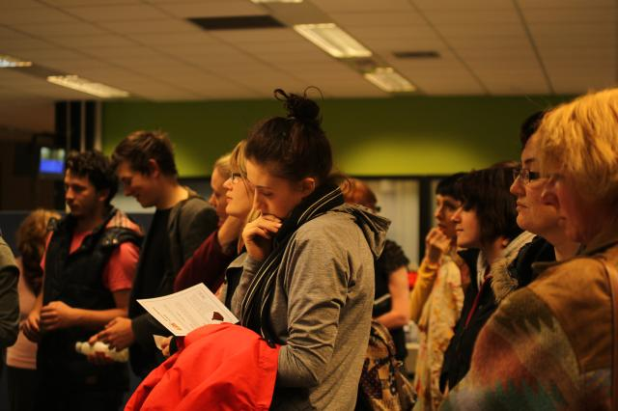
“I spoke with around 25 students – mostly in groups. Everything I overheard about the event, including the food and drink, and libraries was very positive: including “I love libraries” and “They should do this everyday””
“Although students seemed too busy, with lots on the upper floors who did not venture down, they were grateful and interested to receive copies of John Morgan’s writing tips leaflets.”
“The students and staff loved Rachel’s relaxation sessions and tips, and did not seem to be able to take enough of the menu cards and said that they actually wanted and intended to make the suggested recipes.”
“They were totally amazed about the More Books campaign and seemed incredulous that it could possibly be real and wanted to test it as soon as possible. Giving students something above and beyond what they expect created a real buzz and sense of excitement.”

Reflection and some thoughts for future events
Dr. Neil Frude, pioneer of the Prescription Book Scheme in Wales, had originally agreed to take part. Unfortunately he was prevented from doing so by Stress Awareness Day events in Cardiff, however we created a display of books from our dedicated Life Skills collection, which has as its nucleus the Prescription books. The original collection has been expanded to offer help and advice on a range of topics: money, budgeting, loans, landlords, leaving home, exam stress as well as cookery, household hints and passing a driving test etc. This display raised interest amongst visitors who hadn’t realised we had them. We will invite him to visit during this coming year and hopefully record an interview with him for use at a future event showcasing this important collection.
Numerical evaluation of this event was particularly difficult as visitors seemed very reluctant to fill in feedback forms even for the chance to win a prize. All but one of those received said the event was ‘very useful indeed’. The remaining one said it was ‘fairly useful’. In addition, there is currently a university restriction on surveys which precluded our doing the intended post-event survey of students. Informal feedback gathered by talking to the participants suggested that had the timing been different they would have spent more time at the event and they thought more people would have participated. It also suggested that some of the greatest benefit was to people who were unwilling to admit that they were stressed for fear of being seen as failing in some way. This was also evidenced by the private conversations the Sports Centre representative had.
Even though there were good prizes to be won, the number of competition entry forms received was also very small. It seemed that the students were more interested in the value of the events and sessions on offer than they were in the prizes themselves.

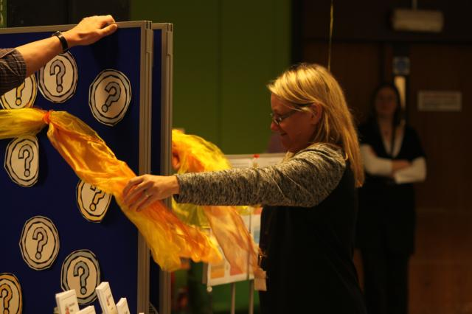
Some photos from the event:
We used the event to launch the More Books Campaign, which was opened by Assistant Director Julie Hart.

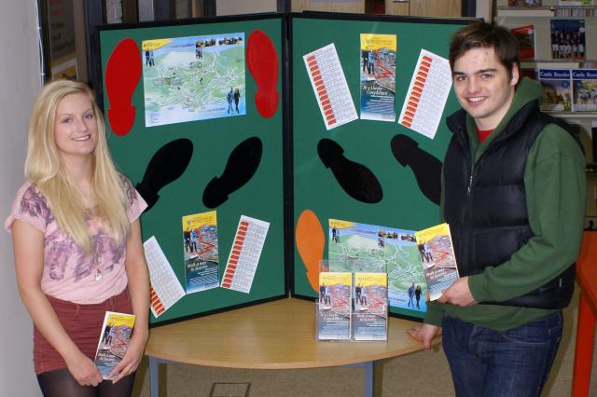
Campus fitness maps
These maps were produced by students from Sports and Exercise Science in collaboration with Information Services. The grant allowed us to fund the printing of 100 of these bilingual, folding A3 maps, which have proved very popular with the students and carry the Welsh Government funding logo.
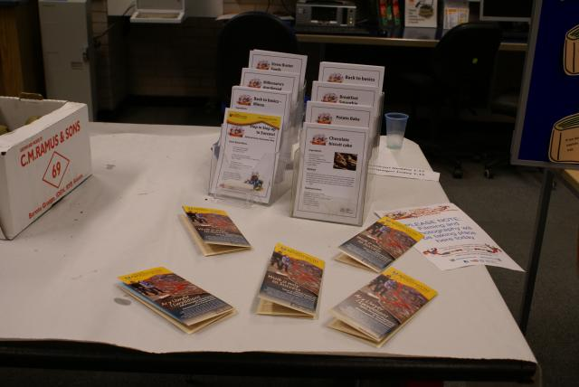
We devised seven Book Menus (three examples below) to highlight books from the Study Skills, Life skills, Modern Fiction and Prescription Books collections. These were produced bilingually, again using the campaign brand, and featured three books on one side and a recipe on the other.
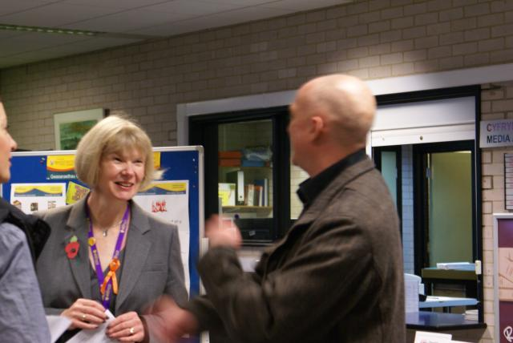
And the Vice-Chancellor came to support the event.

Expenses
Posters, printing, balloons £50
Printing campus maps £120
Printing Book Menus £50
Catering (cake, fresh fruit, juices) £93
Prize – Massage £25

Total: £338

