MARKETING EXCELLENCE AWARDS
2015

Entr y Form

CELEBR ATING AND REWARDING
MARKETING EXCELLENCE IN WELSH
LIBRARIES, ARCHIVES AND MUSEUMS

#marketingawards

ENTRY FORM FOR C ATEGORY 1: DEMONSTR ATING MARKETING EXCELLENCE AND C ATEGORY 2: JOINT MARKETING PROJECT OF THE YEAR

Please complete this section if you are entering Categories 1 and/or 2 only. Please note these details will be used for all future correspondence regarding this specific entry. All fields are compulsory. This information
will be used for publicity, therefore please ensure all sections are completed accurately.

Title | Mrs
First Name | Anne  Jones  Deputy Head of Library Services (Powys Campuses)  NPTC Group Powys Campus  Llanidloes Road  Newtown Powys  SY16 3LB  0845 4086 227  anne.jones@nptcgroup.ac.uk
Surname
Job Title
Organisation Name
Organisation Address
Town
Postcode
Contact Number
Email
Twitter account @
Organisation Profile/Overview (100 words maximum)

NPTC Group Newtown Campus is very rural and forms part of the NPTC Group
comprising of Neath, Queen Street Neath, Afan, Maesteg, Swansea, Llandarcy
Academy of Sport, Ystradgynlais, Brecon, Llandrindod Wells, Newtown and
Fronlas Farm Newtown.

We have 547 full-time students who all have access to the college library.
We have a varied range of resources mainly targeted to curriculum areas.
We have 27 computer stations and 16 laptops for students self study use
within the library, together with 20 laptops to support the curriculum in
classrooms that are bookable by tutors.

CATEGORY ENTERED (please click):

Category 1 – Demonstrating Marketing Excellence

Further education libraries

Category 2 – Joint Marketing Project of the Year

Joint Marketing Project of the Year
The total word count for the section below must not exceed 2500 words. A maximum of two additional
documents may be submitted to support your entry not exceeding 5MB in total or provided as a ZIP file. Alternatively please provide relevant links.

Project title
Enter the title or name of the marketing project – this will be included in all relevant publicity.

Do you love Manga?

Context
Describe the background/reason for this project. What challenges or opportunities were you faced with?

It was very noticeable that the Manga 741 section was under utilised and only the very keen
readers could find the section as it was hidden within the Drawing/Drawings section.
It was our intention to bring out Manga and place it in a very visible position and plan events
to increase the usage without incurring a great deal of cost.

The challenges that we had to face were mainly to do with staffing levels as we were a member
of staff down. The range of Manga books available is very wide and we had to ensure that the content of the resources was suitable for our readers. Manga is very quick to read with a lot of titles in some series therefore it was agreed with the group that there would be a limit on the number of requests purchased each month.

Opportunities - We had a member of staff very keen on Manga and we were able to give a
new lease of life to an existing piece of display shelving. The display was highlighted during
library group inductions and details given of the proposed Manga club. We were fortunate to have support from our manager in Neath and built on the Your choice Your Library Marketing Award winner developed in the Neath campus enabling students to request further Manga stocks and were fortunate to have access to some of the prize vouchers to run an event to bring the event to a time bound conclusion.

Aims and Objectives
State the aims and objectives that were set for this project – where possible these should be SMART
objectives – for example, how many new users or people attending the event were you hoping for? If possible, include budget and timescale information.
What is a SMART objective? Specific, Measurable, Achievable, Realistic, Time-bound

The SMART objective was to specifically increase the usage of Manga books.

Measurable: To be able to measure the increase in usage of Manga books against the previous year.

Achievable: Directly targeting students during induction to raise awareness

Realistic: The event focused on a specific area namely 741. We do have a library budget allocation and it was agreed that we would use some of this to increase the Manga stock. We used existing shelving and printed Manga pictures to cover the shelving the cost was printing 24 A4 sheets @ 6p per sheet, printing of the book club cards and posters making a total of £5.00

Time bound event. In this case from the beginning of September 2014 to the end of December 2014.

Strategy & Planning
Outline the strategy taken to achieve your objectives and justify your marketing approach – did you
undertake any research for example; have your developed new or existing partnerships; did you target a new audience or try a new approach to promoting your services?

We wanted to highlight the Manga resources to all students and encourage new and existing Manga interest. We did visit a public library to see how they displayed their Manga section then built on this by covering the shelving and sides with Manga pictures.

The intention was for the display to be eye catching fun and different using existing and new resources with very little cost.

Tactics and Implementation
Set out the plan of activities undertaken to implement the strategy and evidence these over time and
against budget. Include examples if appropriate – you may append or link to two additional pieces of
supporting evidence – if internet links are included please ensure these will remain live until March 2015. What promotional activity did you undertake; did you use social media and/or traditional media?

Discussions and research completed early summer term. A range of Manga books were
purchased during the summer from the Powys library budget. The display was covered with
Manga pictures at the end of the summer term and our existing Manga stocks were moved
to the new display, together with the new purchases. Manga book club cards were designed.

The Manga display and book club were highlighted during the student induction sessions at the beginning of the September term. If interested in the club students were asked to leave their details at the library issue desk. When the inductions were completed students who had registered an interest were contacted for an informal chat and it was decided to run the first session of the book club on 9 October at lunch time where 13 students attended. During the first few weeks attendance fluctuated between 13 to 19 and then settled to a core group of 10. It was encouraged that students took control of their group who were keen on discussing books, making recommendations and producing origami and drawings of Manga costumes/characters.

The culmination of the project was a Manga competition where students were given a page of Manga with a blank end panel. Students had to produce a caption to end to the storyline and design the accompanying graphic panel. An independent panel judged the entrants and the winners were presented with their prizes. This was an important aspect as it gave a closure to the event but again gave publicity and Manga is being borrowed and new stock requested.

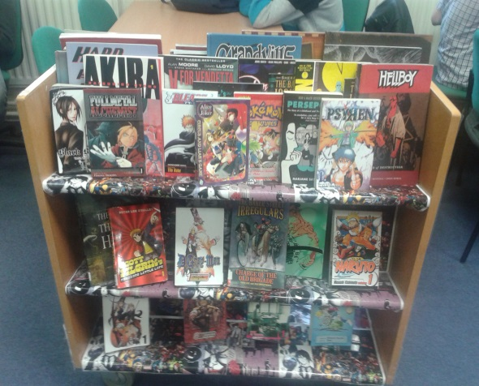

Manga Display

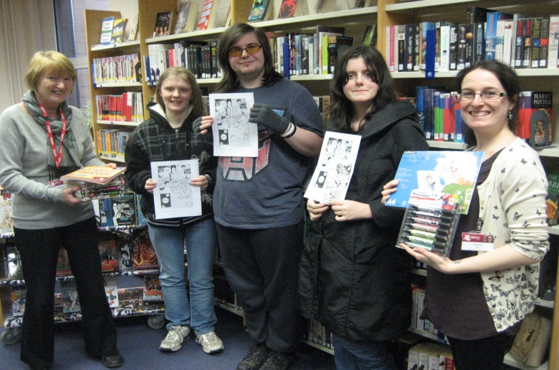

Presentation to the competition winners left to right: Anne Jones staff 3rd Rachel Nevill-Bond who won a book on how to write Manga, 1st prize Ben Pryse-Thomas won £30 worth of Manga, 2nd Zoe Ward who won Speciality Manga pens and paper and Annie Semple staff .

Results/Measurements/Outcomes
Present the results of the project, state whether your aims and objectives were achieved and if they were delivered on time and within budget. Evaluate the project using measurements where possible, such as
number of new members/visitors, added value to the organisation and digital marketing metrics where
applicable (google analytics, Facebook insights, tweetreach). Reflect on what could have been done better;
is the project sustainable, could it be rolled out to other user groups or organisations?

The aim of the project was to highlight the Manga section and increase the issues. The period that the project was running was 4 months and the number of issues rose over 200% as against a full 12 month period of 2013 to 2014. This result together with the buzz created in the library meant that our objective for running the project was achieved.

All students are members of the library but fiction use and footfall has increased this year.

On reflection it would have been beneficial to have had multiple copies of some Manga to encourage group reading and discussion. We were very fortunate to be access to the vouchers to arrange prizes for the competition. This was a low cost project and would be suitable for other organisations to use.
Date of Project
Provide the start and (if appropriate) finish dates of the project.

Beginning of September 2014 to the end of December 2015

Summary
Provide a brief summary of your project (approx. 150 words) to be used for promotional purposes on the website, social media, etc.

Our project was to highlight and increase the usage of our Manga section. We invested in new Manga books then withdrew the existing Manga section and displayed it in a prominent position. We introduced a Manga book club and encouraged students to request Manga books of their choice and discuss these at their meetings where they read, made origami and drew Manga characters. The project ran for 4 months and culminated in a Manga competition where entrants completed an end panel caption and graphics. The results were analysed and the Manga issues had increased over 200% against the whole of the previous year.

ENTRY FORM FOR C ATEGORY 3 – MARKETING CHAMPION OF THE YEAR
Please complete this section if you are entering Category 3. Entries must be nominated by a manager or equivalent – you cannot self-nominate. The nominee must give consent to be nominated.

Please tick the relevant box below -

Library Marketing Champion

Archives Marketing Champion

Museum Marketing Champion

Name of Nominator

Job Title

Organisation Name

Organisation Address

Contact Number

Email

Twitter account @
Why are you nominating this person?
The total word count for the section below must not exceed 1000 words. A maximum of two additional
documents may be submitted to support your entry not exceeding 5MB in total or provided as a ZIP file.

Alternatively please provide relevant links.

• Notable achievements

• Differences made to the service

• Examples of innovative or creative working
• Challenges and barriers overcome

• New partnerships

• Examples of engaging colleagues in marketing

Contact Details of Nominee

Name of Nominee

Job Title

Organisation Name

Organisation Address

Contact number

Email

Twitter Account @

Please submit the entry form and any additional documents to jane.purdie@wrexham.gov.uk and nicola.williams@wrexham.gov.uk by 30th January 2015.

Thanks for entering the Marketing Excellence Awards 2015.

